When forests are managed by farmers :
Implications of farm practices on forest management

Andrieu E¹,2, Sourdril A³, du Bus de Warnaffe G⁴, Deconchat M^{1,2}, Balent G^{1,2}

¹INRA; UMR 1201 DYNAFOR, F-31326 Castanet Tolosan, France
²Université de Toulouse, UMR DYNAFOR, INRA / INP-ENSAT, BP 32607, 31326 Castanet Tolosan, France
³INRA, MONA, 65 Boulevard de Brandebourg, 94205 Ivry-sur-Seine Cedex, France
⁴Arbre et Bois Conseil, Domaine du Chalet, route de Chalabre, 11 300 Limoux, France

Abstract [12pt Times New Roman, Bold, Left justified]

Farm forests, i.e. forests managed by farmers, are important components of French landscapes. Farmers, who do not have knowledge in sylviculture in general, harvest them for firewood and timberwood, but also use them for hunting, mushroom harvesting or grazing. The social and ecological functions of these woods call for a better understanding of their management. These private woods are mainly small (< 25 ha) and thus are not submitted to French management regulations. We present the conclusions of three multidisciplinary long term studies, in south west of France, based on historical, social and technical analyses of the particularities of these woodlots. Results showed that the traditional social system (“house-centered system”) is still influencing forest management, despite its loosing of importance. Woodlots are parts of the agricultural systems but some cultural features limit the implementation modern forestry practices. The roles of farm forests have to be considered on a larger landscape scale perspective.

Keywords: Rural forest, private forest, management pratices, SIG, ethnology

1. Introduction

In France, 28 % of the territory is forested and around 75% of this forested area (i.e. 10 millions of ha) belongs to a multitude of private owners (around 3.5 millions). A large part of these private woods are farm forests. Farm forests are forested areas managed and used by farmers, whatever are the legal system and the structure of the stands (Normandin 1996). They represent 17% of private forest in the whole territory and up to 50% in several departements in South-West (Cinotti and Normandin 2002). Despite their important cultural and ecological functions in agricultural landscapes (Balent et al. 1996, Sourdril 2008) and their potential role in the sustainable development of rural areas, management modalities of farm forests are still poorly known. Moreover, their surface area is decreasing because of their conversion into common private forest, due to sales and inheritance to non-farmers (Cinotti and Normandin 2002): farming and forestry are thus more and more disconnected (Larrère and Nougarède 1990; Cardon 1999).
A characteristic of French private forest is the small size of the properties: half of them have an area of less than 25 ha. Yet regularly obligations do not impose particular forest management in these small properties, unlike in larger ones for which a management schedule (Plan Simple de Gestion, regulatory document that is both a guide for forest management and a traceability document) approved by the Centre Régional de la Propriété Forestière (public institution supporting private sylviculturists to manage their forests) is compulsory. As a consequence, management in small private woods is not described in any document or inventory that hampers the study of current practices and the build up of forest management history.
The objective of this paper is to present an original combination of retrospective mapping from aerial photographs of farm forest management for 60 years with anthropological analysis of the drivers of forest management and forestry practices. We thus have to analyze forest management practices thanks to aerial photographs and to interviews analysis. Interviews were also used to assess forest representational systems that are linked to practices (Lemonnier 1994), and the relationships among stakeholders concerned by farming and forestry (social networks).

2. Methodology

2.1 Study sites

Studied woods are located in the LTSER (Long Term Ecological and Sociological Research) platform « Vallées et Coteaux de Gascogne » in southwestern France, at ~ 60 km south-west of Toulouse, in 5 rural parish territories (43° 16’ N, 48° 43' E, 200 - 400 m a.s.l.). This hilly region is characterized by a temperate climate with oceanic and slight Mediterranean influences. Two types of soil occur in the study site: superficial calcareous soils (superficial terrefort) and non-calcareous acid molasse (brown acid and brown washed soils) (CRAMP 1995). The region is not densely populated and is still largely agricultural. The dominant tree species of the woods are sessile oak (Quercus petraea Lieblein) and pedunculate oak (Q. robur L.), mixed with hornbeam (Carpinus betulus L.) (Cabanettes and Guyon 1994). Wood management system is traditionally either coppice or coppice-with-standard: coppice is assumed to be logged each 30 years by clear cutting, mostly to produce fire wood, and a part of the standard trees can be cut as well, to be sold or used as timber wood.

2.2 History of forest logging

We selected a set of woods (total surface area ~ 100 Ha) with a common history, i.e. they were all included in a whole larger wood two centuries ago that has been fragmented. Aerial photographs are the most appropriate cartographic data that allow reconstructing logging history at a fine scale. We chose seven missions conducted by the French National Geographical Institute and by the French National Forest Inventory (1942, 1953, 1962, 1977, 1984, 1996, 2006) in order to obtain a regular temporal sequence. The photographs were analyzed using optical stereoscopy in order to detect and date cuttings: we circumscribed polygons defined by their cover classes, based on tree height (Bakis and Bonin 2000 ; Muraz et al. 1999): cuttings (C), young coppice (R) and mature stands (M) (described in De Warnaffe et al. 2006). These cover classes were digitalized on aerial photographs previously georeferenced with ArcGis®. We adapted the photo-interpretation method the most frequently used (regressive photo-interpretation method, which consists in digitizing from the most recent to the older photograph (Muraz et al. 1999): indeed, at the fine scale of our study, superimposed digitalized maps do not fit perfectly because of inherent imprecision of georeferencing process, which induces artefactual edge changes (see Andrieu et al. 2008 for details). Resulting maps were crossed in a SIG to obtain a synthesis map (1942-2006) summarizing logging history.
Between 1942 and 2006, we assessed temporal changes (Mann-Kendall test for monotonic trends) in cutting system : cutting number, cutting total surface area per year, cutting mean surface area, ratio of areas coppiced with vs. without standards, cutting shapes complexity (Area Weighted Mean Shape Index, and Area Weighted Mean Patch Fractal Dimension). Matches between the shapes of cuttings and cadastral parcels were estimated visually. To test whether both ecological factors and forest accessibility can influence the number of cutting between 1942 and 2006 (elevation, slope and aspect, distance for streams, forest edge and ways, geology and soil type), we built log-linear regression model (log link function) on a random sample of 2000 points generated in the study area. Significance of effects was assessed by comparing deviance reduction of nested models with χ² tests (anova function, stats package, R) and for any significant factor, contrasts tests were used to compare regression coefficient estimates among levels. We analyzed wood maturation through changes in the proportion of surface area of cuttings, mature and immature stands. To assess spatio-temporal stability of mature stand habitat, we built cores of mature stand areas with potential edge effect of 10 m to 50 m for each period: maps were pooled in order to detect areas that were continuously mature since 1942.

2.3 Analysis of forest management practices

In order to analyze forest management practices we selected 7 woods with different surface areas (0.7 – 11.2 ha) on which we had rebuild the history of logging. They belong to 11 private owners: 4 active farmers, 7 retired farmers and 7 non-farmers. We used semi-directive interviews to analyze practices, know-how and ethnobotanical knowledge of private owners, and to define social networks. Both interviews and visits in the woods allowed rebuilding « mental-maps » of cuttings realized by the owners or their family. At home, we asked the owner to draw on an empty map the shape of the cutting procedure as far as he could remember. In the wood, the owner completed the information obtained (seeing logging signs helped the owner remind) and modify the previous map drawn. These “as told” practices (mental maps, Fig. 1) where crossed with “observed” practices (from aerial pictures) in a GIS. During the interviews, the owner was also asked to describe the nature of the cutting procedure, cuttings people involved, season and equipment used, standards maintained, and what use was made of the wood that was cut since 1938. From these descriptions, two hypotheses have been tested. First, retired farmers are traditionally the managers of the woodlots after the transfer of the farm ownership and management to their son (Nougarède 1999). We tested thus the hypothesis of such a separation between knowledge and / or practices of forestry and farming which can be led by this transfer (Nougarède 1999; Cardon 1999). Second, the inheritance of woodlots to non-farmers could lead to a separation of forestry practices between farmers and non-farmers, each having their own knowledge and social networks. We tested thus whether the management of woodlots by non-farmers is disconnected or not from agriculture.

3. Results and Discussion

Whereas they constitute a large part of forested area in France, modalities and history of management of small private woods remained widely misunderstood because of the difficulty to collect and analyze historical information. Based on the analysis of historical documents and of semi-directive interviews, our studies show clearly how complex in space and time forest management by private owners can be.

3.1 Comparing mental maps and photo-interpreted aerial photography: benefits from the comparison between “as told” and “observed” practices

First, there was a good agreement between the “as told” and “observed” practices. Three types of disagreement were detected: (1) cutting operation is reported at the time of the interview without being identified on the aerial photograph, generally due to an high density of the standards; (2) cutting operation is detected by the aerial photograph but not reported at the time of the interview, due to an incomplete memory; and (3) rarely a great difference in the cutting areas for a given date or cutting date very different for a given area which can point out the difficulty of the informant to legend the “mental map”. Since it is not possible to verify the memory of the owners, we should place greater faith in the aerial photographs to detect the cutting places; however cutting places choices and cutting procedures cannot be understood without the memory of the owners. The combination of the two methods is therefore required to understand forest management through space and time.
Second, photo-interpretation showed some evolutions of management practices between 1942 and 2006. In our study site, the management consisted in numerous small cuttings (< 1 ha), mainly coppiced with standard (65% of the cuttings). The type of management (coppice with or without standards), the shape of the cuts, and their spatial localization (i.e. their aggregation) remained stable through time. However, even if the number of cutting remained stable, their mean size decrease since around 1980 (0.43-0.63 ha - depending on the year - before 1980, 0.16-0.20 ha after), which caused a decrease of total cut surface area (3.8 to 1.4 ha). This pattern associated to general information collected on rural life changes in the interviews indicate that the origin of the decrease of total cut surface area is not rural depopulation and the subsequent abandonment of forested parcels. It is very likely to be either the energetic transition to fossil fuel that decreased the needs in firewood (which is the main use of wood in our study site), or the lack of time available for forest management activities (and more widely the management of semi-natural habitats) in a context of change of farmer activities during the last decades. An important ecological consequence of the reduction of wood harvest is the maturation of the stands. In our study site, stand age structure changed drastically and we are now assisting to a homogenization of stand maturity toward mature trees: in 1942, 6 % of wood surface area was mature and 88% immature whereas in 2006 59 % was mature and 39% immature. Such changes of age structure can lead to a change of biodiversity patterns, like the replacement of assemblages dominated by early successional species by assemblages dominated by late successional species.
Photo-interpretation showed that the main part of the woods has been submitted to a moderate harvest intensity and has been cut once (27 % of surface area), twice (38 %) or three times (16 %) (Fig. 2). In appearance, around 15% of the wood surface area has never been cut since 1942. However these areas tally mainly with ancient abandoned fields or parts which have been already cut just before 1942. When these areas are excluded, only 3% of wood surface areas that were mature in 1942 have never been cut between 1942 and 2006. These preserved areas are scarce and small, particularly when a small edge effect of 10 m is attributed to them (9 isolated patches, with a surface area of less than 0.3 ha). Species assemblage linked with old stands, characterized by the presence of dead wood and natural cavities, could thus be rare or missing in these farm forests. Another important result of our study is that the number of consecutive cuttings was not related to ecological or accessibility variables. This means that the choice of cutting localization was done on the basis of other criterion like land register (cuttings follow the shape of cadastral parcels, even if besides the cuts becoming smaller, their boundaries matched lesser in 2006 than in 1942). In addition, the choice depends on the conception of the owners - but not only of the owners, also of neighbors of the forest or of others managers - of how their woods have to be managed, because of particular events or agricultural needs (lightning, need for timberwood for the renovation or the construction of a barn, needs for stakes for the pastures for example). These ideas led us to try to understand in a more precise way and through anthropological investigations the local management of the forest and the different people involved in it.

3.2 Who is doing what in the forest? From the classification owner and manager to the classification owner, decision-maker and performer

Following our interviews and direct investigations with the people involved in the forest management, we realized that the classical typology of the relationships between stakeholders and the woods (owner/ non-owner and manager / non-manager) - leading to the idea that forest were progressively managed without any influence of the farm practices on the forest land - did not fit our studied situation because : (1) some stakeholders can be decision-makers (i.e. the person who makes the strategic decisions about the general management of the forest and who takes technical decisions during field activities) without being the owner of the woodlot (i.e. the person who legally holds the land); (2) some stakeholders can manage forests without being owner or decision-maker. We thus have to consider together property, decision and action: our typology is then owner / non-owner, decision-maker / non-decision-maker and action performer / action non-performer. These characteristics are non exclusive, for example a performer can occasionally make decisions or an owner decision-maker can occasionally carry out some forest activities. The term of « manager » is then meaningless in our study context. Therefore, even if the owner is not a farmer - anymore or at all - farmers can be involved in the forest practices at some point.
Following the idea that forest can be hold by retired father, while the son deal with the farm, we decided to try to understand with our new typology the different roles shared by fathers and sons in the forest management. Four father / son couples have been interviewed. All fathers were retired farmer, owners and decision makers, two were performers (the two other were occasional performers). No son (active farmers) was owner but all were decision-makers together with their fathers, three were the main performers and one was occasional performer. Retired farmer always helps their son in the farm. When the woods belong to the father, then a strong relationship between agricultural and forestry practices remains, due to the implication of both father and son on both agricultural and forest lands. Even if they sometimes disagree about the way forests have to be managed, the management of the forests belonging to retired farmers is not dissociated from agricultural practices. Moreover most retirees keep considering and are considered to be as farmer as active farmers themselves. In the process of transmission of the property, if the forest can be separated from the farm for a while because being kept by the father while the farm is given to the son, this process is never definitive and the forest will automatically be transmitted to the son at the death of his father; it is finally never detached from the farm except on the paper.
What happens when non farmers are owners of forest land? Five non-farmers were owners and two were non-owner but were performers or decision-makers. Whereas non-farmers have no professional link with farming activities, we found that their forestry practices were strongly influenced by farming activities because (A) they can have relatives who are farmers and they integrate their practices, know-how and representations of the forest; (B) forests are embedded in an agricultural matrix so logging can be dependent of agricultural practices (for example, a farmer can ask his neighbors to manage the forest edge adjacent to his field, or a cutting can be delayed to avoid a deterioration of the adjacent crops); (C) techniques can percolate through social networks (neighbors, friends).
To conclude, these multidisciplinary studies illustrate that the specificity of rural forest management, particularly the high spatio-temporal variability of cuttings, the strong links between forestry and farm practices even when owners are “non-farmers”, and the organization of activities within farming families.

References

Andrieu, E., du Bus de Warnaffe, G., Ladet, S., Heintz, W., Sourdril, A., Deconchat, M., 2008. Mapping the felling history in small-sized woodlands, Revue Forestière Française, 60: 667-676.
Bakis, H., Bonin, N., 2000. La Photographie aérienne et spatiale. Que sais-je, n° 1700, PUF, Paris.
Balent, G., 1996. La forêt paysanne dans l’espace rural. Biodiversité, paysages, produits. Etudes et Recherche sur les Systèmes Agraires et le Développement, INRA Editions, 29.
Cabanettes, A., Guyon, J.P., 1994. Relations entre gestion et structure dans les systèmes boisés d’exploitations agricoles. In Colloque « Agriculteurs, agricultures et forêts », Cemagref et INRA, Paris, 12-13 décembre 1994.
Cardon, P., 1999. Un capital dormant. La transmission patrimoniale de la forêt paysanne en Franche-Comté. Terrain, 32.
Cinotti, B., Normandin, D., 2002. Exploitants agricoles et propriété forestière : où est passée la « forêt paysanne » ? Revue Forestière Française, 4: 311-327.
Chambre Régionale d’Agriculture de Midi-Pyrénées, 1995. Les grandes ensembles morpho-pédologiques de la région Midi-Pyrénées.
De Warnaffe, G., Deconchat, M., Ladet, S., Balent, G., 2006. Variability of cutting regimes in small private woodlots of south-western France. Annals of Forest Science, 63: 915-927.
Larrère, R., Nougarède, O., 1990. La forêt dans l’histoire des systèmes agraires. De la dissociation à la réinsertion. Cahiers d’Economie et de sociologie rurales, 15-16: 11-38.
Lemonnier, P., 1994. Choix techniques et représentations de l’enfermement chez les Anga de Nouvelle-Guinée. In Latour B et Lemonnier P (éd.), De la préhistoire aux missiles balistiques, La découverte, Paris, pp. 253-272.
Muraz, J., Durrieu, S., Labbe, S., Andreassian, V., Tangara, M., 1999. Comment valoriser les photos aériennes dans les SIG. Ingénieries, 20: 39−57.
Nougarède, O., 1999. La transmission de la forêt paysanne. Les bois dans la vie de la famille agricole. In: Bois et forêts des agriculteurs, Actes du colloque, Clermont-Ferrand, 20-21 oct. 1999, Cemagref Editions, pp. 309-333.
Sourdril, A., 2008. Territoire et hiérarchie dans une société à maison Bas-Commingeoise : Permanence et changement. Des bois, des champs, des prés (Haute-Garonne), PhD dissertation Univ. Paris X.

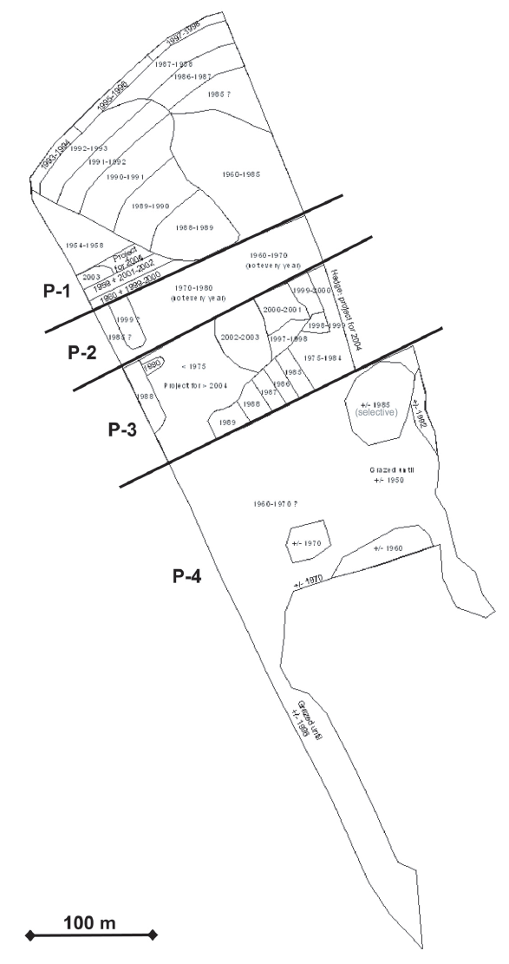

Figure 1: Mental map of the cutting zones for one of the woodlots. Bold lines indicate the property limits.

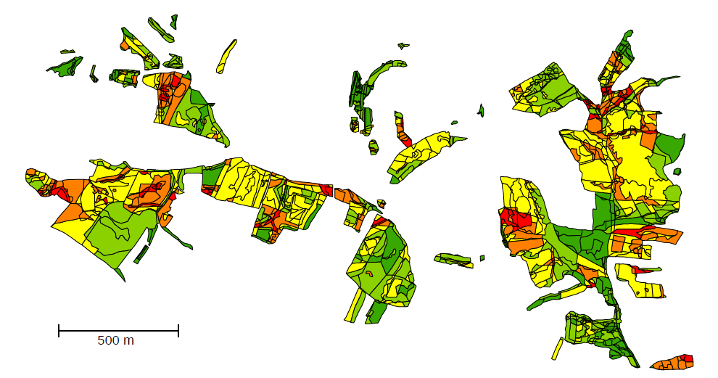
Figure 2: Synthesis map of cutting number between 1942 and 2006, derived from the analysis of aerial photographs: dark green = 0, light green = 1, yellow = 2, orange = 3, red = 4 and more. Black lines are the delimitation of different cutting events.

